2022 Archaeological Survey & Mapping in Belize
University of New Hampshire
Field School Session: January 2-22, 2022

Preliminary Information
(Updated September 2021)

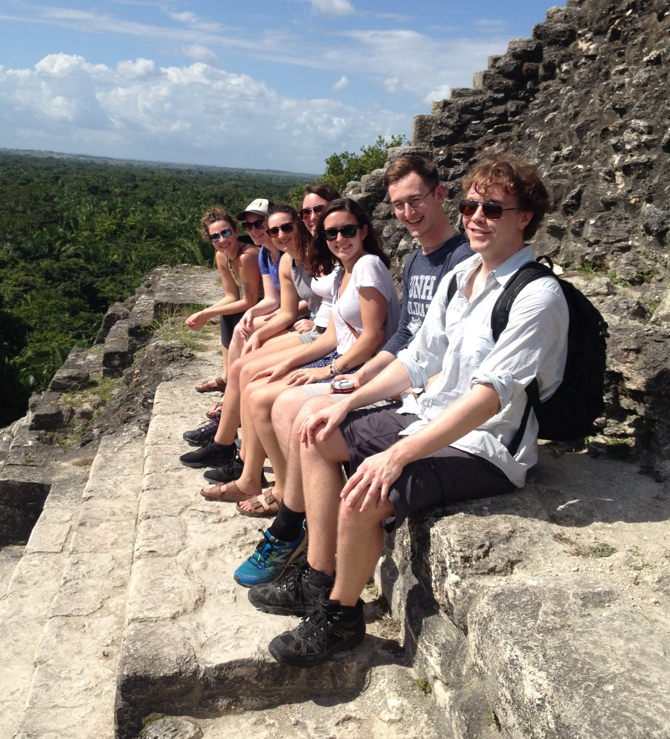
Field School 2019
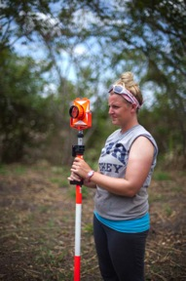
Dr. Eleanor Harrison-Buck, Program Director
Department of Anthropology
Huddleston Hall, Office 311
1-603-862-4742
belize.fieldschool@unh.edu

For Additional Information Visit:
https://cola.unh.edu/cola-study-abroad/programs/belize-archaeological-survey-mapping
Application Deadline: September 30, 2021

For an application, go to: https://unh-global.via-trm.com

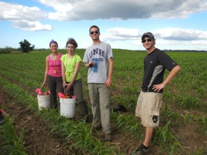
To Apply
If you want to participate on the Belize Archaeological Field School, you must first complete an online application through the UNH Via study abroad portal prior to the application deadline.

First-time users will be instructed to set up a profile. Once prompted to search for the program you’re interested in, you should search for "Belize" and find the "UNH Belize J-Term Program". Select the program to access the online application and follow the instructions. If you have already set up a UNH Via profile, you can access the program page and start your application directly at: https://unh-global.via-trm.com/client/programs/2375.

There are no pre-requisites or additional requirements to join the program aside from the standard UNH eligibility requirements. However, it is important for all prospective participants to be fully aware of the conditions of the field school and expectations of the participants:
1) The project requires all participants to live and cooperate in close quarters with others and involves hard physical labor in a hot, tropical environment, often hiking into remote parts of the jungle.
2) Roads are not always going to be paved and in good condition and some riverside sites are only accessible via canoe.
3) Survey entails hiking through the jungle while wearing snake guards and a backpack (carrying up to a gallon of water).

4) Excavation (also expected of all students) entails lifting up to 25 pounds, swinging a pick, and using a shovel, in addition to more detailed work using a trowel, dental pick, and paint brush.

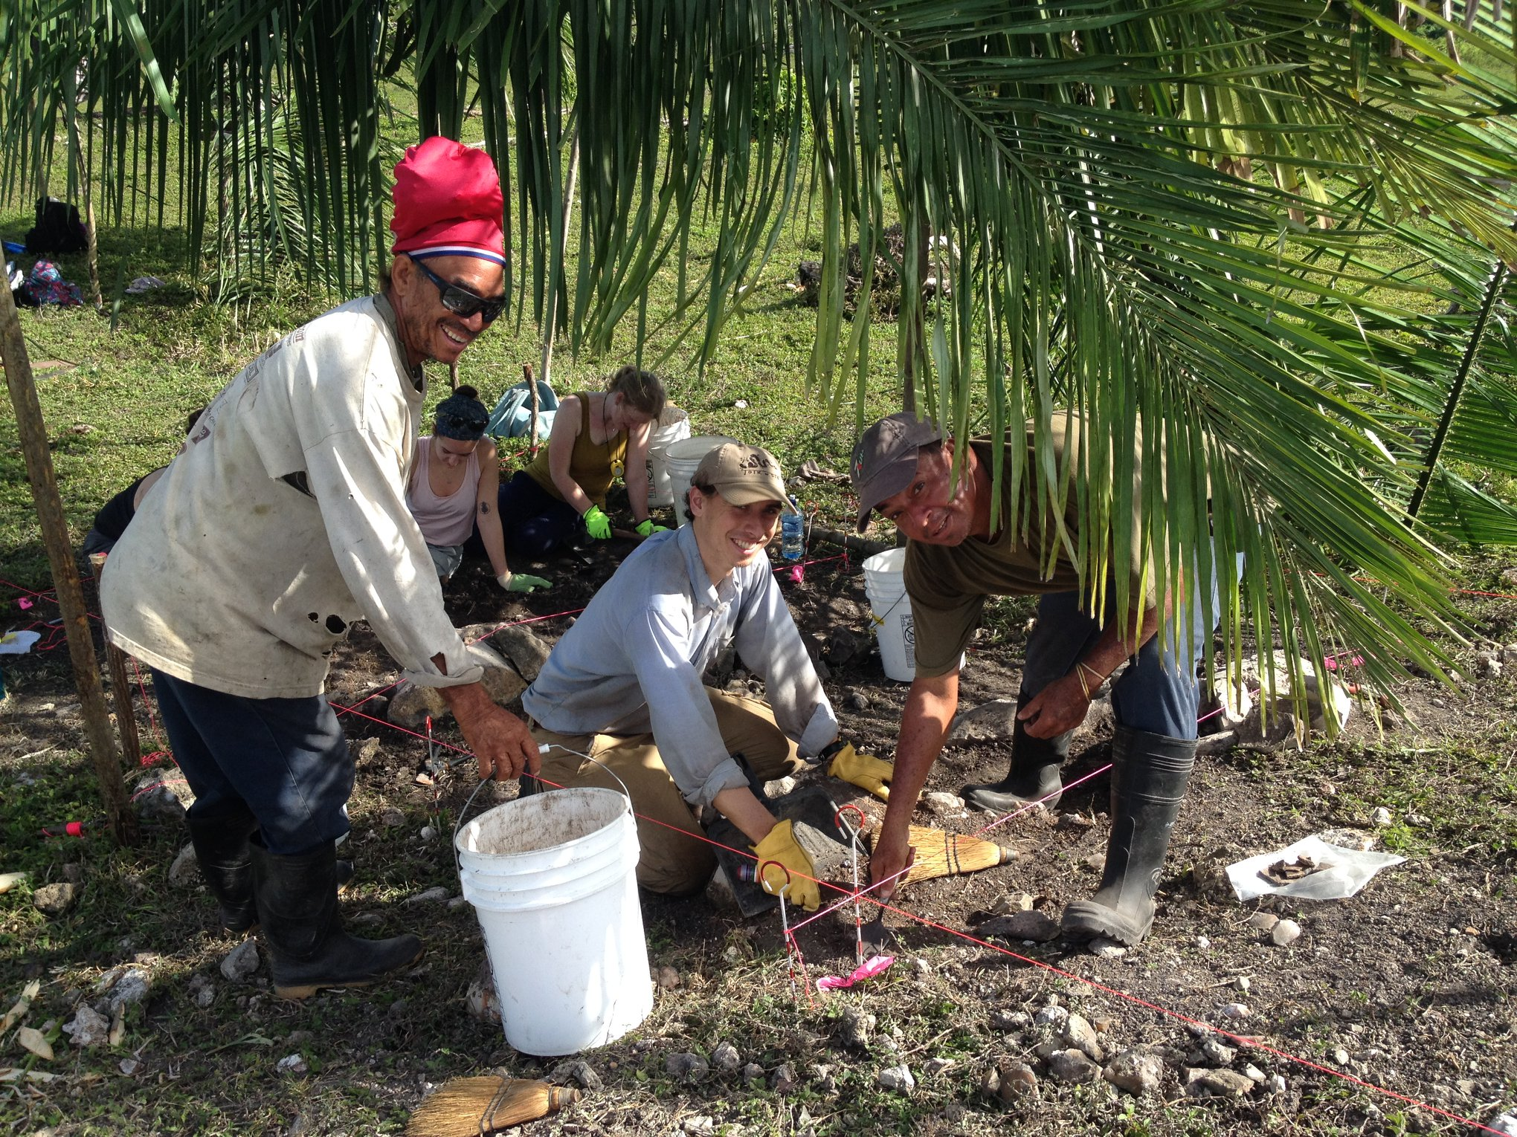
The closing date for applications is September 30. All applications for the program go through a review process. Acceptance to a study abroad program is based on this review, fulfillment of GPA and academic requirements, and approval by the COLA Center for Study Abroad. You will be notified if you have been accepted to the program no later than October 29. All approved applicants are required to pay a deposit of $500 that must be received by November 15. Accepted students will be provided instructions on how to pay this deposit online.

Background on the Program
The UNH-managed Archaeological Survey & Mapping in Belize (ANTH 674) is a 4-credit intensive course that involves hands-on training in field reconnaissance, survey and mapping of archaeological sites, and the use of ArcGIS software in the production of site maps. Students also will rotate teams and get some exposure to field excavation techniques and lab work. The field course is primarily aimed at preparing students how to accomplish all aspects of field survey and mapping and focuses on the recording of ancient Maya archaeological sites in the eastern Belize River valley. This program in Belize is offered through the University of New Hampshire (UNH) and managed through the COLA Center for Study Abroad and is supported by the Department of Anthropology and the UNH Global Education Center at UNH and will be of interest to a wide range of students, including those studying archaeology, geography, forestry and environmental studies, architecture and urban planning, and geology, among other fields. The 2022 season during the January Term will run from January 2 to 22 and will entail survey and mapping of archaeological sites, and laboratory processing and analyses of recovered artifacts and other surface finds.

The field school will be based out of Tillet’s Lodge in Crooked Tree (shown below), located less than an hour north of the Belize International Airport. The village is located in a beautiful spot along the Western Lagoon—the largest inland wetland in all of Belize This 16,400 acre wetland system is part of a protected wildlife sanctuary that hosts up to 400 different species of birds, including the largest bird in the Americas, the endangered Jabiru, which uses the nearby area as its nesting ground. Crooked Tree is a small, rural Creole village, consisting of dirt roads, a handful of restaurants, and simple thatch and cement houses. The village is surrounded by wetlands, jungle, and areas of cleared pasture where cattle are regularly seen roaming. Students will share rooms at Tillet’s Lodge (2-4 students a room). The lodge (shown below) will provide three meals a day to all field school students and staff, including a daily breakfast, pack lunch for field excursions, and a sit-down dinner in their thatch palapa dining room.

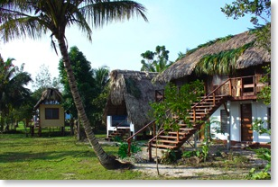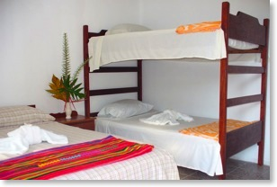

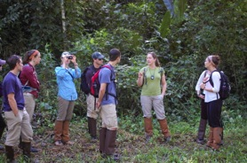
Dr. Eleanor Harrison-Buck has been doing archaeology in Belize for over 25 years and initiated the BREA project in 2011. She will be responsible for all aspects of the field course, including lectures, in-field instruction and supervision, and direction of all field and laboratory work. Two experienced graduate-level Teaching Assistants will assist in the field course, helping to train students in survey and mapping of archaeological sites in the BREA study area. Permission to survey and excavate sites in the BREA study area has been granted to the PI by the Belize Institute of Archaeology.

The Archaeological Survey & Mapping in Belize course is not a typical study abroad—the program offers college students a rare opportunity to be active participants in the archaeological investigations of ancient Maya sites in the BREA study area. The results of the fieldwork contribute directly to Dr. Harrison-Buck’s ongoing BREA research project. The course is limited to no more than 12 students. In addition to the Director, the BREA project includes five staff members, including graduate and PhDs trained in Maya archaeology, survey, mapping, and ArcGIS software. Because we keep the field school small, the program offers an incredible staff to student ratio, with intensive, one-on-one instruction in archaeological field and laboratory methods from staff who all have years of field experience and can share their various areas of expertise in Maya archaeology.

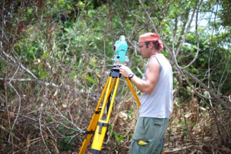
The course consists of nightly lectures on a variety of topics related to survey and mapping and ancient Maya settlement archaeology. Evening labs will include hands-on practicums, such as artifact analyses with one-on-one training from Program staff, all professionally trained archaeologists with many years of experience. During evening labs, students also will receive training in post-processing data and creating maps in ArcGIS. The goals of the course are to: a) provide students with an overview of ancient Maya settlement archaeology and b) offer students a thorough understanding and hands-on working knowledge of how archaeological sites are recorded through various survey and mapping techniques, as well as the final map production using ArcGIS software.

The program also includes an excursion with several archaeological sites tours of nearby Maya ruins, including the large sites of Altun Ha and Lamanai, as well as optional trips during a free long weekend.
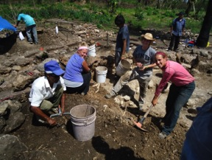
About BREA
The Belize River East Archaeology (BREA) project represents the first comprehensive archaeological survey and excavation to be carried out in the eastern half of the Belize River watershed (See map). The Belize River is a large and navigable waterway with its headwaters in Belize and Guatemala. The river flows 180 miles (290 km) across central Belize to where it drains into the Caribbean Sea and the entire watershed is around 11,000 km². The mid-to-lower reaches of the Belize Watershed east of Roaring Creek comprise the BREA study area.
Map of Belize showing BREA study area in gray.
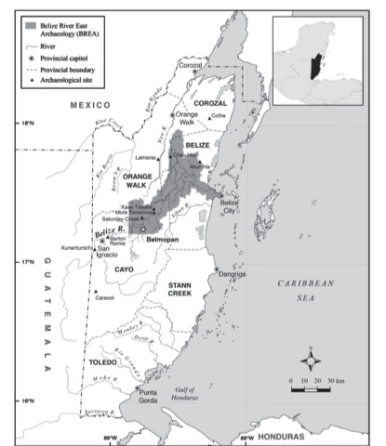
Measuring over 2000 km², the BREA study area includes the lower trunk of the Belize River and several of its major tributaries, including Saturday Creek, Beaver Dam Creek, Labouring Creek, Spanish Creek, and Black Creek. Our overall goal is to develop a more comprehensive settlement history for the eastern half of the Belize Watershed and get a better sense of the settlement density along the main trunk of the Belize River and its tributaries (see Map figure for extent of
BREA study area).

For the latest information on the BREA project and to learn more about the sites we have investigated previously, please visit: https://brea-project.org
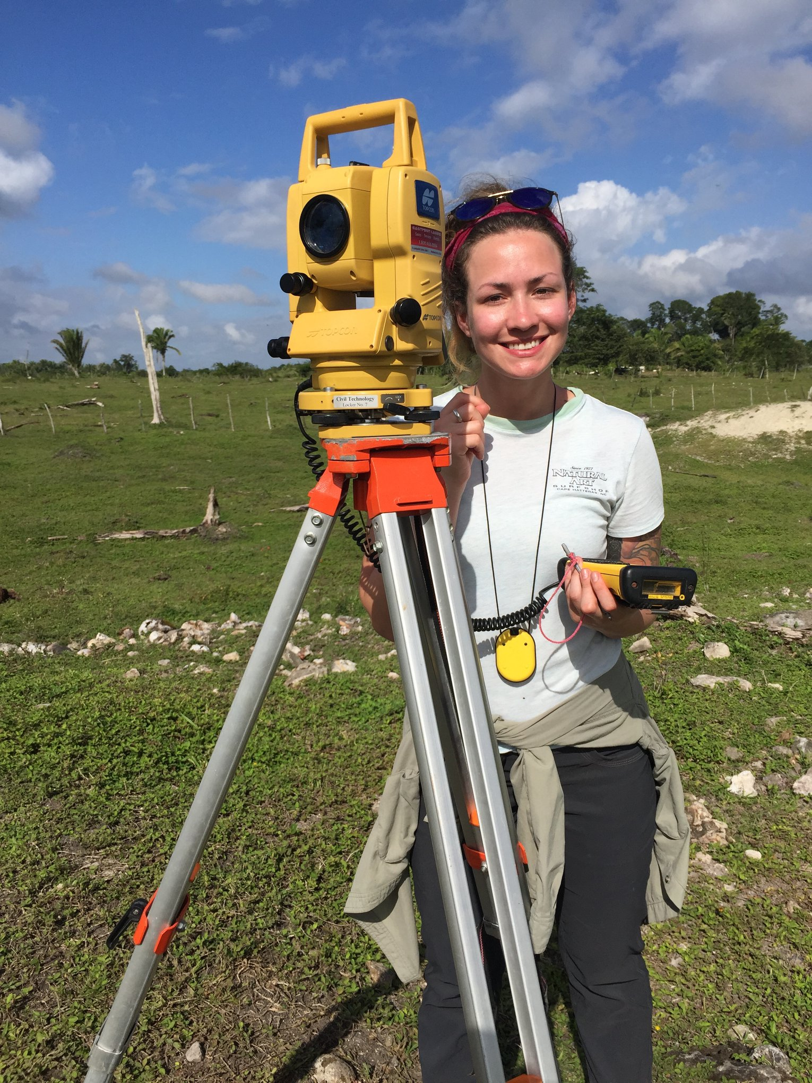

2022 Field Research Plans
Preliminary plans for the upcoming field season will involve work at several different locations in the BREA study area, not more than a 30-40 minute drive from our base camp at Tillet’s Lodge. We have been investigating the Maya settlement patterns north of the major ancient city center of Chau Hiix. One site in this area that has been the focus of our mapping and excavation efforts is Ek’tok. This ceremonial center contains several pyramids and plaza groups and shows a long history of occupation extending from Preclassic to Spanish Colonial times (ca. 900 B.C.-A.D. 1600). In the upcoming season, we will continue to investigate this and other sites in the area, including the minor ceremonial center of Waxak Nicte’ in Biscayne village. If time permits, we may also investigate other nearby sites, including Jabonche and Kunahmul, two Maya sites located just outside of the major ancient Maya city center of Altun Ha. Several of our surveyors also will continue to conduct reconnaissance in the surrounding area, where we have found an abundance of ancient Maya settlement. This is a chance to discover previously unrecorded ruins hidden in the forest!

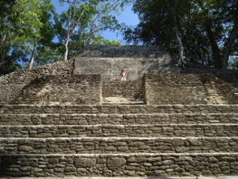
Estimated Cost
The cost of the program is estimated:
- Study Abroad Program Fee: $2320
- Plus 4 credit hours of tuition: general Jan Term tuition rates apply
- Mandatory UNH fees (administration, technology, registration, and insurance fees) $221
- Airfare, estimated : $650-750

The Study Abroad Program Fee includes:
- All student transportation in Belize once the project begins until it ends
- Weekend excursion to visit and tour several restored archaeological sites
- Lodging at Tillet’s Lodge (students will share a room with other students)
- Three meals/day (7 days/week while at the lodge)

Passport and Visa Information: If you don’t already have one or if your current passport expires before November, you must apply for a passport (expedited) immediately. The process is not difficult but there are significant delays and even expedited processing is taking 10-12 weeks! Visit the US Department of State website for more information: https://travel.state.gov/content/travel/en/passports/apply-renew-passport.html.

US citizens do not need a visa to travel to Belize for stays shorter than 6 months.

Insurance Information: All students are covered on a comprehensive international insurance and travel assistance plan. You can find more details on this coverage online through the UNH Global Education Center: https://www.unh.edu/global/insurance-0

Belize Health and Safety Information
- Belize is currently at a Level 4 according to the Centers for Disease Control (CDC). However, COVID-19 vaccination rates are rapidly increasing. NOTE: All travelers to Belize must present a negative COVID test 72 hours prior to arrival. COVID-19 Vaccination is required by our host community for all participants.
- For more information on health and safety for travelers to Belize: https://wwwnc.cdc.gov/travel/destinations/traveler/none/belize
- US Department of State, Belize Country Information: https://travel.state.gov/content/travel/en/international-travel/International-Travel-Country-Information-Pages/Belize.html

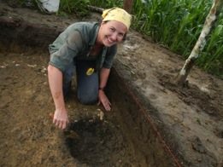
Receiving Credit for the Program
Students attending the University of New Hampshire are required to enroll in ANTH 674, Archaeological Survey and Mapping in Belize, for the Jan Term session. Students at other universities can easily be admitted to the UNH program for the January Term and enroll in the course, but must fill out an application. The COLA Center for Study Abroad will register all program participants.

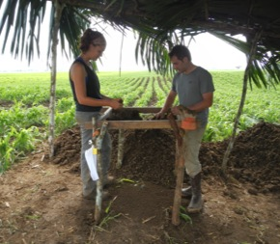
Description of Course Objectives
ANTH 674 is an intensive, 4-credit-hour course offered during the Jan Term, designed to introduce students to the methods used to collect and analyze archaeological data in a hands-on field setting. Students will receive instruction in survey, mapping, and field excavations of archaeological sites. Our anticipated student to staff ratio on this course is roughly 3:1, ensuring that students will receive a great deal of individual attention and training in archaeological field techniques.

Course Requirements & Grading
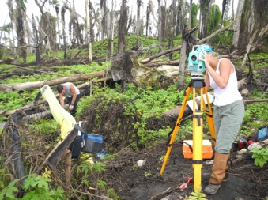
Grades are based on student participation and their performance in daily field activities and nightly labs with scheduled days off for travel or relaxation at the Tillet’s Village Lodge (for daily schedule see below). Assisted by program staff, each student will be graded on their participation in the survey, mapping, and excavation of archaeological field sites in the study area. During the evenings, students will be required to attend lectures and practicums where they will learn about Maya archaeology, settlement mapping, and how to produce site maps using ArcGIS software. At the end of the course, students will be graded on a final field practicum. This mapping exercise will involve surveying a site, mapping it with a Total Station, and producing a digital map in ArcGIS. Throughout the course, students will keep a survey notebook that they also must submit at the end of the course as part of their final grade.

Grading breakdown for ANTH 674 is as follows:

Field & Lab Participation: 25%
Survey Notebook: 25%
Final Mapping Exercise: 50%

Tentative Program Scheduling
Tuesday, November 25, 12:40-1:30p.m. Mandatory Pre-departure Orientation Meeting for University of New Hampshire Students, Huddleston, Archaeology Lab (Rm. G16)

Typical Field Day  5:30am Coffee & Breakfast served  6:00am Depart for the field  11:30am-12pm Break for lunch  2:45pm Leave the field  3:30pm Back in camp  Free time 5:45-6:30pm (1 hour artifact washing 2-3 afternoons/week)  Dinner 6:45-8:00pm Lab | January 2 You are responsible for your own travel to and from Belize. You must be at the airport in Belize City on January 2. Group assembles at Goldson International Airport (Belize City). Once everyone has arrived, we will travel by van to Tillett’s Village Lodge (~45 minute ride).  January 3 Orientation day with tour of BREA study area and Crooked Tree Museum. Afternoon tour of Altun Ha archaeological site.  January 4 Regular field and lab schedule (see Typical Field Day schedule).  January 9 Program-sponsored field trip to Maya site of Lamanai.  January 10-15 Regular field and lab schedule. January 16-18 students free to travel (pending health and safety in country).  January 19-20 Regular field and lab schedule. January 21 Last day in camp (Final Mapping Exercise, pack, etc); Evening Farewell Party.  January 22 We'll load everyone’s belongings and take students back to the Belize International Airport for departure to US.

