For immediate release: University of New Hampshire
Virtual Artist Talk: Artist Michael Menchaca and Dr. Sara Withers
Wednesday, November 10, 2021, 1:10 – 2:00, via Zoom
Contact: Kathy McKenna, Administrative Assistant Manager Museum of Art, UNH 603-862-3712

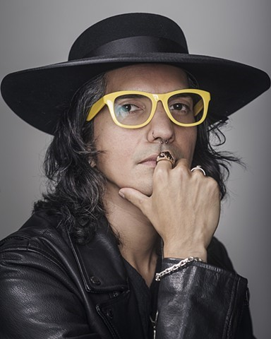
DURHAM, NH – Join artist Michael Menchaca and Dr. Sara Withers, Senior Lecturer in Anthropology, in their virtual discussion of Menchaca's mural Hope Is a Discipline and its relation to contemporary topics in Latin America including indigeneity, immigration, and the relationship between globalization, power, and surveillance.
The discussion will take place over Zoom, Wednesday, November 10, 2021 at 1:10 – 2:00 pm. All are welcome to attend; please register using this link or via our website.
The eye-catching mural, Hope is a Discipline, designed for UNH’s Paul Creative Arts Center exterior elevator tower, uses intricate imagery from pop-culture and the modern, corporate world, (i.e., emojis) blended with ancient, mythological symbology to “challenge existing notions of race and identity while lifting the spirits of our most vulnerable communities…” According to Menchaca, they use a “personalized lexicon of animal archetypes and narrative pattern designs presented in the design assist in translating, preserving, and mythologizing contemporary stories of social and economic inequality, racial prejudice, class discrimination, and online surveillance practices.”
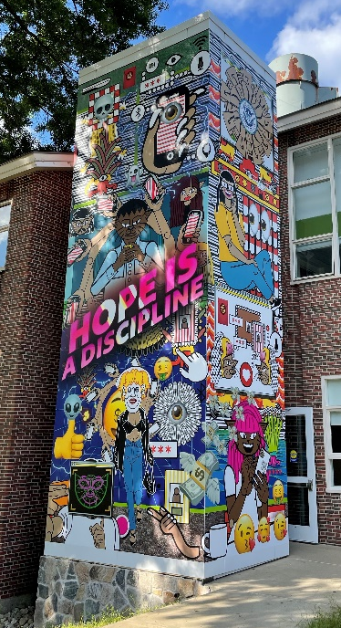
Many of those issues will be at the forefront of their discussion with UNH anthropology lecturer, Dr. Sara Withers.
Dr. Withers, in addition to her teaching responsibilities at UNH, has dedicated her time to sharing the lives and experiences of refugees, especially those here in New Hampshire. She was Project Manager for the 2010 film Uprooted: Heartache and Hope in NH and the Humanities Expert for the film, Refugees of Shangri-La (2013-2014), about Bhutanese refugees in New Hampshire and the United States. At UNH Dr. Withers teaches a variety of anthropology classes including those with a focus on Latin America and issues of gender.
UNH Museum of Art Collection Study Area
Four other prints by Menchaca, from the Museum of Art’s permanent collection, will be featured in the Museum’s Collection Study Area from November 1 – December 10, 2021.
Menchaca’s mural design was chosen by the Committee for Campus Aesthetics 2021 from four final designs. The mural was funded by the Coe-Hall Fund.
Tips for Visiting
The mural is easily viewable from Academic Way. The PCAC is located on the UNH Durham campus at 30 Academic Way. There is metered parking directly in front of the mural.
Museum Closed: November 11 and November 25 -28. Museum hours of operation during the academic year: Monday, Tuesday, Wednesday, and Friday: 10 a.m.-4 p.m., Thursday: 10 a.m.-6 p.m., Saturday: 12 - 4 p.m., Closed Sunday and University holidays.
Visitors are welcome on the Durham campus at this time. Masks must be work in all indoor spaces regardless of vaccination status. Masks are not required outdoors. UNH monitors campus and regional data daily and will reevaluate if conditions change.
Artist’s Website: https://michaelmenchaca.com/home.html
Image Credit: Michael Menchaca, Hope Is a Discipline, 2021, digital mural, 28’ h x 21.6’ w.
Photo of Michael Menchaca by: Anthony Francis
Follow and subscribe to the Museum of Art on Facebook, Twitter , YouTube, and Instagram

Museum of Art * Paul Creative Arts Center * 30 Academic Way * Durham, NH 03824 (603) 862-3712 * https://cola.unh.edu/museum-art/

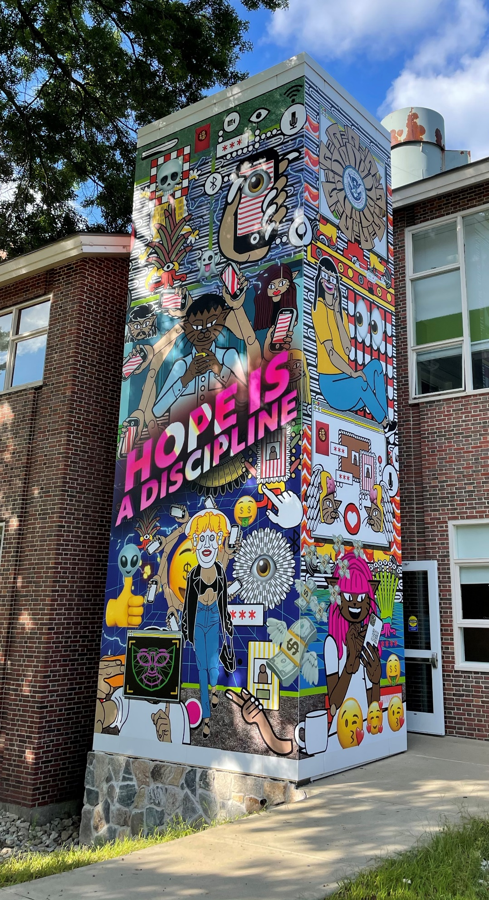
Image Credit: Michael Menchaca, Hope Is a Discipline, 2021, digital mural, 28’ h x 21.6’ w.

