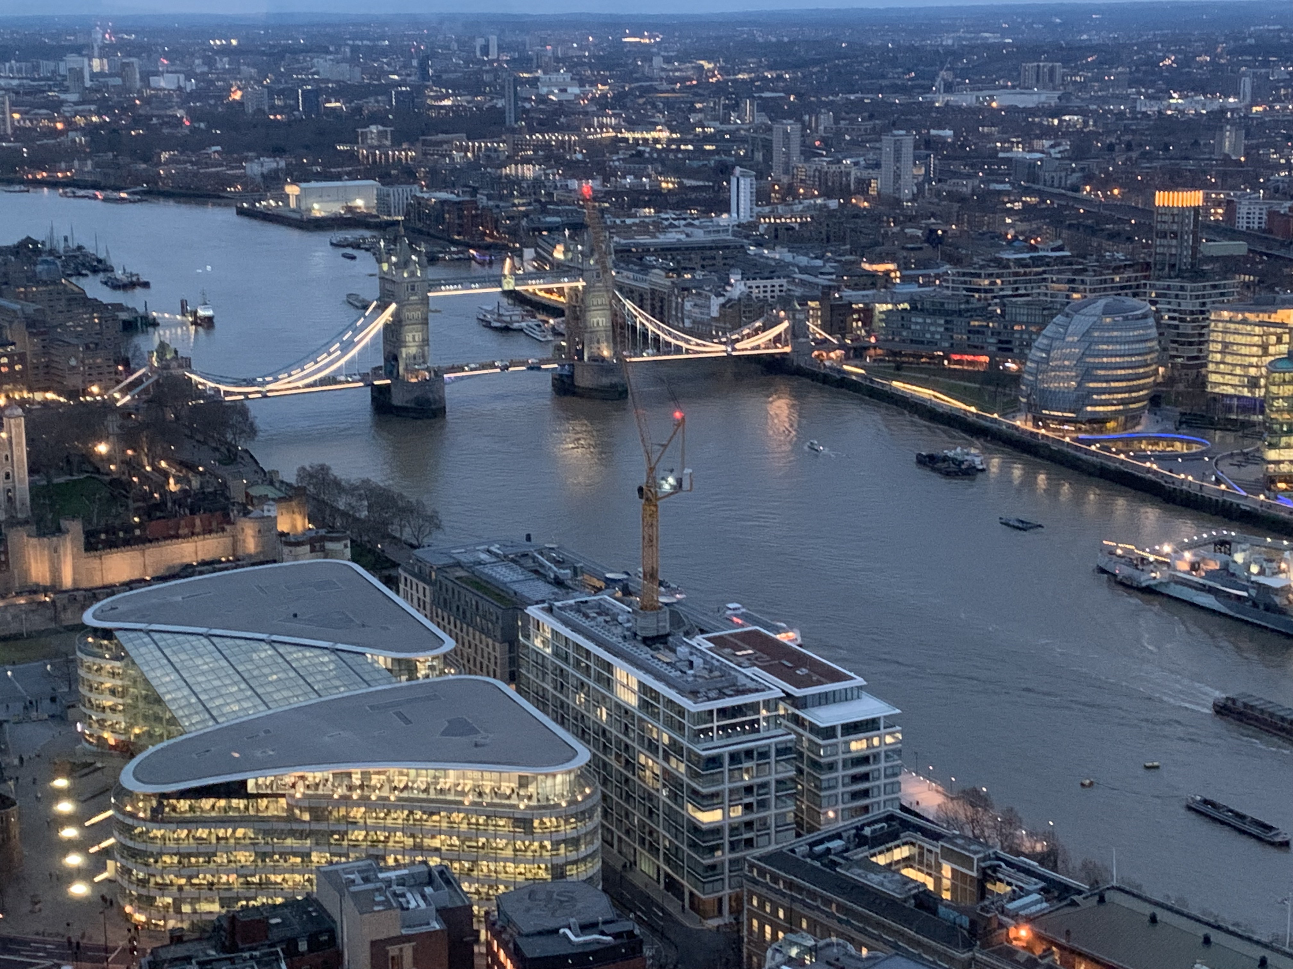

English 703T/803T Travel Writing
London, England
J-Term 2026
Dates: Dec. 29, 2025 - Jan. 17, 2026
One week online and two weeks in London
4 credits

Recommended pre-requisite: ENGL 501 or 621 or 623 or permission of instructor
Counts towards an English Writing Minor, the English Major, and as a Writing Intensive Course

What is the London Travel Writing J-Term Course?

English 703T/803T Travel Writing is an upper-level writing course that asks students to explore the world around them – in this case, London – and write thoughtful essays blending their experience with research and observations of place. Students are expected to have a working knowledge of and experience writing creative nonfiction and/or journalism. The course starts with a week of online readings and writing at home and then moves the show to London for two weeks.
This is a course for the independent and the adventurous. Aside from group excursions and the hours that we meet in class weekdays, students are on their own to roam London to find topics for their travel essays. At first, students will have writing prompts to help them acclimate to their new surroundings. The second week, they have the freedom to delve deeper into a subject they explored the first week or launch a fresh idea. London is one of the most vibrant, exciting cities in the world; there is no shortage of material to investigate. A typical day for a London J-term travel writer is a combination of exploring (a visit to the Tate Modern, a noontime concert at St. Martin-in- the-Fields, a tour of Wembley Stadium), reading (classmate’s work and published essays), and writing.
We meet as a class weekdays, some days in the hostel and others in various sites around London. Class time will range from reading discussions and workshopping student writing to a two-hour writing exercise. For the first half of the London stay, students will post 500-word essays each day to the program’s Instagram page. During the second week, students will develop one of those Insta-Essays into a longer narrative.
In addition, we have group excursions, including a bus tour of the city, two dinners, a trip to Cambridge, an evening at the theatre, and a weekend day trip.
Jan. 3- 17, 2026 students will stay at Hyde Park View Hostel https://www.smarthostels.com/hyde-park-view. This recently renovated hostel situated at the top of Hyde Park and Kensington Gardens is central many London delights, including Kensington Palace, Buckingham Palace, the Victoria and Albert Museum, Portobello Market, Regent’s Park, and Speakers’ Corner. The National Gallery, Covent Garden, West End theatres, music venues, and more restaurants than you can count are also a short hoof away. London is, if anything, a walkable city. When tired, you can enjoy the city bus and underground (known as the Tube) system to get you from Point A to Point B.

Course Schedule and Itinerary:

Dec. 29, 2025 - Jan. 2, 2026: Students will delve into travel writing through a series of four modules posted on Canvas. Each module addresses a different element of travel writing and contains a combination of explanation, reading, and writing assignments. Each weekday of a J-term course equals one-week of a standard semester so prepare to devote three to six hours a day to course work. All assignments will be submitted to individual OneDrive folders. In addition, students will research London and prepare their wish list for places and events to research when they arrive.

Friday, Jan. 2, 2026 Fly overnight to London. Take notes on the trip, detailing what you’re experiencing (use all of your senses), feeling, and thinking. Chronicle dialogue and interactions.
Saturday, Jan. 3, 2026 Arrive in London and head to Hyde Park View Hostel, 16 Leinster Terrace, London W2 3EU. https://www.smarthostels.com/hyde-park-view
4 p.m. meeting in the hostel’s cafeteria
Sunday, Jan. 4 Hop On Hop Off Bus Tour of London. Meet in hostel lounge at 10 a.m. Take lots of notes and photos. Jot down sites you passed that you’d like to visit.
Welcome dinner. Meet in hostel lounge at 6 p.m.
Monday, Jan. 5 9:30-11:30 a.m. Hostel Bar lounge/ Gathering content
- Discuss “The Longest Crawl”
- Visit a place you saw during the Big Bus tour that captured your curiosity. Could be a major tourist destination (Westminster Abbey; Buckingham Palace; Tower of London) or perhaps a park, or a street with quirky shops. Take notes, jot down impressions, talk to people.
Tuesday, Jan. 6 9:30-11:30 a.m. Hostel bar lounge/ Scenes
- Discuss “Swallowing Fear”
- Visit a museum (e.g. History of London Museum, Charles Dickens Museum; British Library; National Portrait Gallery, Tate; Wembley Stadium).
- Write a scene from the visit, either focused on your reflections (internal) or something you learned about the museum, or artifact, or history, or anything else external.
- Post a photo/video and 500-word mini-essay #2 on Instagram.
Wednesday, Jan. 7 10 a.m. Meet in hostel bar lounge and we will head to the British Museum for class. Afterwards, experience the London outdoors (e.g. Hyde Park, the London Zoo, Regent’s Park, Hampstead Heath, any walking tour).
- Discuss on Canvas Discussions “A Street Corner in Paris”
- Write an Instagram post with special attention to sensory detail -- what you saw, heard, touched, smelled, tasted during your outdoor adventure.
- West End Theatre production TBD
Thursday, Jan. 8 9:30 -11:30 a.m. Hostel bar lounge/ Interviewing & content collecting
- Discuss “My Beirut Hostage Crisis”
- Experience London culinary icons (e.g. afternoon tea at Claridge’s; Harrod’s food court; fish & chips at Sea Shell of Lisson Grove). Interview a food vendor about his/her specialty.
Fri., Jan. 9 Cambridge (Links to an external site.) Day Trip. Meet in the bar/lounge at 9:30 a.m. We will then head to King’s Cross Station and Platform 9 ¾ to catch a train to Cambridge.
- On Canvas Discussions, discuss “Such Perfection”
- Each of you will be assigned one place/person/institution to explore in Cambridge and post an essay and art about it on Instagram.
- Writing: Continue work on long essay What other content do you need?
Sat., Jan. 10 Open day. Suggestion: Portobello or Camden markets (Watch your valuables!! Crowded street markets famous for pickpockets.)
Sun., Jan. 11 All-day excursion TBD
Mon., Jan. 12 9:30-11:30 a.m. Hostel bar lounge/ Beginnings
- Discuss “London” from Bill Bryson’s The Road to Little Dribbling
- Explore London
- Writing: Using your Instagram posts as a springboard, write a draft of a 1,500-word essay. The draft must be complete by Tuesday's class.
Tues., Jan. 13 9:30-11:30 a.m. Hostel bar lounge/ workshop essay drafts
- Discuss“Born to Travel”
- Explore London
- Revise essay. Gather more content. Write more scenes. Add more commentary.
Wed., Jan. 14 9:30 a.m. Meet in Hostel bar lounge for excursion TBD
- Writing: Continue revising the essay
- Revise essay. Review structure (does it pose narrative tension?), clarity, specifics
Thurs., Jan. 15 9:30-11:30 a.m. hostel bar/lounge
- Discuss “Summer in the Far North”
- Workshop essays
- Revise essay. Expand the key moments, condense the rest. Is the message clear?
Friday, Jan. 16 9:30 a.m. Meet in hostel bar/lounge
- Last class excursion TBD.
- Revised essay due in OneDrive at 5 p.m.
- Final Dinner. Meet in bar/lounge at 6 p.m
Saturday, Jan. 17 Fly home

What’s it going to cost me? Estimated costs for 2026

 | NH Res. Undergrad. | Non-NH Res. Undergrad. | NH Res. Grad. | Non-NH Res. Grad.
UNH J-Term Tuition  (4 credits) | $1,884 | $2,128 | $2,200 | $2,420
Estimated Program Fee* | $950 | $950 | $950 | $950
UNH Technology & Registration Fees | $46 | $46 | $46 | $46
UNH Study Abroad Administrative Fee | $100 | $100 | $100 | $100
UNH Mandatory International Insurance Fee | $35 | $35 | $35 | $35
Total | $3,050 | $3,294 | $3,366 | $3,586

*The estimated program fee covers 14-nights lodging and breakfast, Big Bus tour of London, two dinners, one theatre ticket, day trip to Cambridge, and another day trip TBD

Not included: Airfare; public transportation in London; meals other than the ones mentioned above; other travel, international cell phone

Dates of Travel: January 2 – January 17, 2026. Students will arrange their own transportation. Itinerary subject to change.

What about scholarships and financial aid?
- Use of financial aid is limited for January Term, but students are encouraged to contact the Financial Aid Office for guidance
- There are some scholarship opportunities for January Term study abroad programs. Students are encouraged to apply to two UNH funds in particular (applications available in August for J-Term):
  - COLA Study Abroad Awards. Students must be COLA majors, multiple funds available. Find application information online at https://cola.unh.edu/center-study-abroad/resources/financial-aid-scholarships.
  - UNH Global Study Abroad Scholarships. Multiple scholarship funds which emphasize academic merit, financial need, and diversity. Find application information online at: https://www.unh.edu/global/unh-global-undergraduate-education-abroad-awards. Questions? Contact the Global Education Center at: study.abroad@unh.edu

How do I apply?

- The online application and instructions can be found on the “Apply” section of the program website (unh-global.via-trm.com/program_brochure/2373)
- Deadline: Final applications will be accepted through October 1, 2025. The deposit deadline is October 15, 2025.

If I’m accepted, what happens next?

- You will need to put down a non-refundable $200 deposit after final notifications of acceptance.
- You will be billed full tuition and program fees in November and full payment will be due to UNH Business Services in early December.
- You’ll have some paperwork to do; UNH Global will be in contact with you during our pre-departure planning meetings to provide instructions.

If I’m accepted, how do I get to London?

- The craft of travel writing requires the writer to navigate the unfamiliar, to learn how to reach destinations and how to seek information. Thus, students are expected to arrange their own travel to and from London, which includes making their way to our hostel. To aid this first challenge, Prof. Hertz will provide students with a list of transportation options from Heathrow and Gatwick airports to the hostel.

What else will I have to do?

- Apply for your passport if you do not have one. IMMEDIATELY!! Passport applications can take up to 18 weeks to process, from the day of application submission to the day of arrival.

